4th March 2014
YOKOHAMA Announces New Winter Tyre for Europe – “W*drive V905”

Tokyo – The Yokohama Rubber Co., Ltd., announced today that it would begin selling a new winter passenger car tyre across the European continent ahead of the 2014 autumn/winter snowy season. The “W*drive V905” is a successor to the popular “W*drive (V902A/B)” and will be available in sizes from 15 inch to 18 inch.

The new tyre’s conventional model, the “W*drive (V902A/B),” was launched in 2007 as the winter tyre in the YOKOHAMA “.drive” series, one of the Company’s core tyres for overseas markets, especially Europe. The new “W*drive V905” maximizes the edging effect that contributes to stability on snow and ice. It also features a tread pattern that enhances the tyre’s snow and water drainage and a new compound comprising various materials, including Micro Silica and Orange Oil. As a result, the “W*drive V905” achieves a greatly improved level of performance on snowy and wet roads, as well as on icy surfaces. In addition, a reconfiguration of the tyre’s surface contact area results in improved snow traction and drainage when running on wet roads while maintaining the conventional model’s outstanding performance on dry roads. The new compound and a lighter-weight construction contribute to lower rolling resistance and higher fuel efficiency.

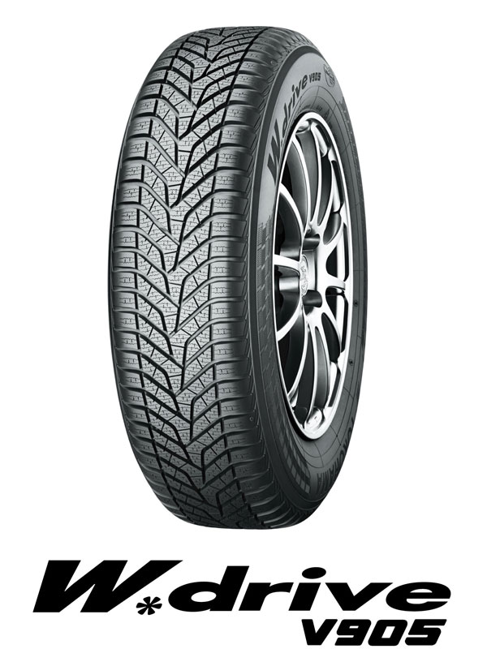

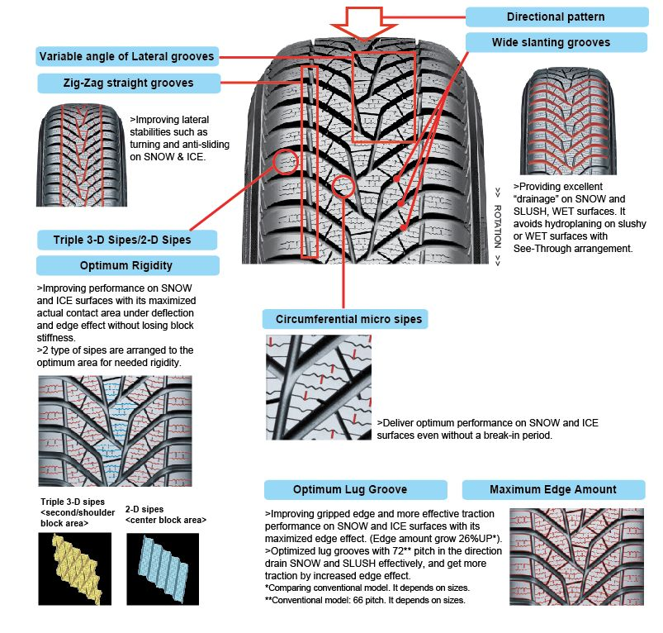
Release Reference Material
Technical approach－Tread pattern

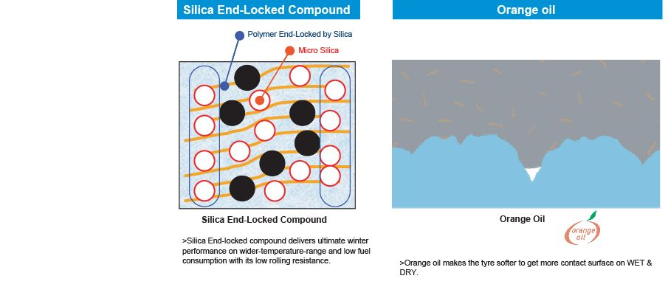
Technical approach－Tread Compound

Technical approach－Construction

